Bebe Moore Campbell National Minority Mental Health Month
Posted July 1, 2020
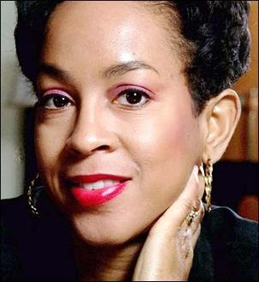
By Source (WP:NFCC#4), Fair use, Link
Since 2008, July has been known and celebrated as “Bebe Moore Campbell National Minority Mental Health Month,” (better known today as simply Minority Mental Health Month or BIPOC Mental Health Month). This national observation was created to bring awareness and focus to the obstacles and struggles that minorities face in caring for their mental health and in honor and remembrance of a phenomenal woman, Bebe Moore Campbell.
Bebe was born February 19, 1950, in Philadelphia, PA. In her early years, her parents divorced and her father moved to North Carolina, where Bebe spent the summers of her youth. Growing up in the drastically different northern and southern states during the 50’s and 60’s, she witnessed the racial segregation of our nation and its impact first-hand. She attended the University of Pittsburgh and was the only African American in her dorm while she pursued her degree in Elementary Education. These experiences helped to shape her perspective and fuel her inspiration for her career as an author, journalist, teacher, and mental health advocate.
Bebe was the co-founder of the Urban Los Angeles chapter of NAMI (National Alliance on Mental Illness). She was a longtime advocate for individuals from diverse communities for mental health education, access, and support. “People of color, particularly African Americans, feel the stigma more keenly. In a race-conscious society, some don’t want to be perceived as having yet another deficit,” said Bebe.
She was also very open about her personal experiences of mental illness within her family and teamed with up her friend Linda Wharton-Boyd to create the dedicated month for minority mental health awareness. “Once my loved ones accepted the diagnosis, healing began for the entire family, but it took too long. It took years. Can’t we, as a nation, begin to speed up that process? We need a national campaign to destigmatize mental illness, especially one targeted toward African Americans… It’s not shameful to have a mental illness. Get treatment. Recovery is possible.”
Bebe passed away in 2006 following a battle with brain cancer. Linda carried on Bebe’s campaign along with friends, family, and other advocates and in May of 2008, a resolution passed to make July Bebe Moore Campbell National Minority Mental Health Month.
As we continue to live in a time of social injustice, racial inequity, prejudice, and a worldwide pandemic – we are all faced with the reality that mental health awareness should not be confined to an occasion, but something that should be freely discussed and addressed any day of the year. So as we all come together to learn from each other and add new resources to our wellness toolkits, let’s remember that we can take the lessons we learn this month and apply them to our daily lives.
To learn more about Bebe Moore Campbell, please visit the following resources:
- https://www.thehistorymakers.org/biography/bebe-moore-campbell-41
- https://en.wikipedia.org/wiki/Bebe_Moore_Campbell
- https://www.britannica.com/biography/Bebe-Moore-Campbell
- https://www.npr.org/templates/story/story.php?storyId=6546082

